EXPERIMENT NO 7

CREATE TABLE exp7_bank(
bankcode VARCHAR2(3) PRIMARY KEY,
bankname VARCHAR2(50) NOT NULL,
headoffice VARCHAR2(50),
branches NUMBER CHECK(branches > 0)
);
INSERT INTO exp7_bank VALUES('FBI','FEDERAL BANK OF INDIA','DELHI',800);
INSERT INTO exp7_bank VALUES('ICI','ICICI BANK','MUMBAI',1200);
INSERT INTO exp7_bank VALUES('SBI','STATE BANK OF INDIA','MUMBAI',2500);
INSERT INTO exp7_bank VALUES('BOB','BANK OF BARODA','GUJARAT',1500);
SELECT * FROM exp7_bank;
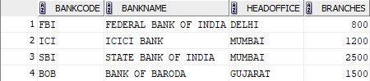
1.
COMMIT;
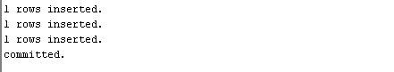
SELECT * FROM exp7_bank;


2.
INSERT INTO exp7_bank VALUES('ABX','AXIS BANK','MADRAS',900);
savepoint A;

SELECT * FROM exp7_bank;
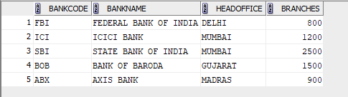

INSERT INTO exp7_bank VALUES('ICL','ICL FINCORP','ERNAKULAM',400);
savepoint B;
SELECT * FROM exp7_bank;
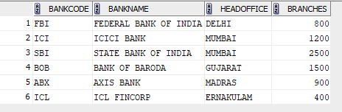
3.
ROLLBACK TO A;
SELECT * FROM exp7_bank;
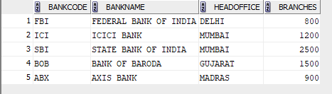

EXPERIMENT NO 8

CREATE TABLE STUDENT_EXP8(
NAME VARCHAR2(30) NOT NULL,
PHY INT ,
chem int,
MATH INT
);
INSERT INTO student_exp8 VALUES('A',16,17,30);
INSERT INTO student_exp8 VALUES('B',23,24,40);
INSERT INTO student_exp8 VALUES('C',25,25,49);
INSERT INTO student_exp8 VALUES('D',15,20,27);
INSERT INTO student_exp8 VALUES('E',21,23,44);
INSERT INTO student_exp8 VALUES('F',15,15,17);
INSERT INTO student_exp8 VALUES('G',20,9,14);
SELECT * FROM student_exp8;
ALTER TABLE student_exp8 ADD TOTAL_MARKS INT;
UPDATE student_exp8 SET TOTAL_MARKS= PHY+ chem + MATH;
SELECT * FROM student_exp8;
ALTER TABLE student_exp8 ADD PASS_OR_FAIL VARCHAR(20);
UPDATE student_exp8 SET PASS_OR_FAIL='PASS' WHERE TOTAL_MARKS >50;
UPDATE student_exp8 SET PASS_OR_FAIL='FAIL' WHERE TOTAL_MARKS <50;
SELECT * FROM student_exp8;
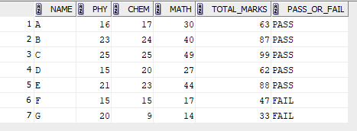
1.
GRANT SELECT ON student_exp8 to c24csa15;
SELECT * FROM c24csa15.STUDENT_EXP_8;
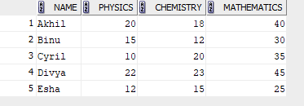
2.
revoke select on student_exp8 from c24csa15;

EXPERIMENT NO 9

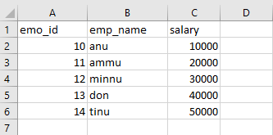

CREATE TABLE emp (
eno NUMBER(4),
ename VARCHAR2(20),
sal NUMBER(7,2)
);
SELECT * FROM emp;

